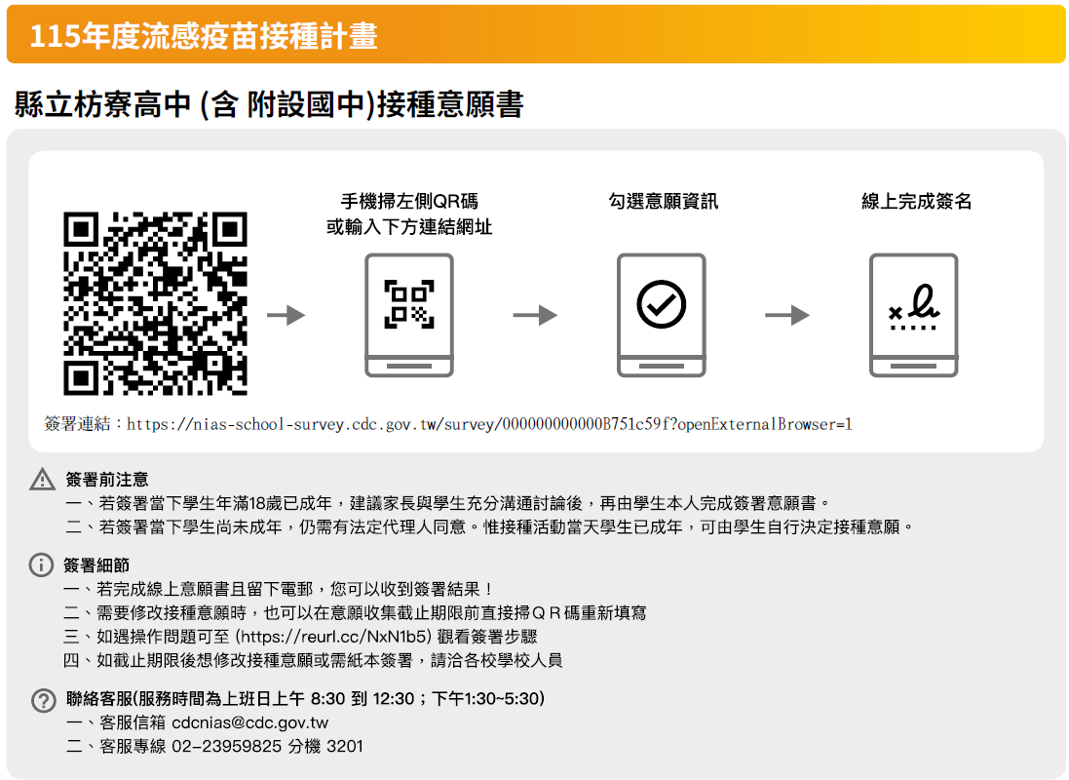

也可以使用枋寮高中專屬流感簽署網址:
https://nias-school-survey.cdc.gov.tw/survey/agreement?c=d112&p=%E6%B5%81%E6%84%9F%E7%96%AB%E8%8B%97%E6%8E%A5%E7%A8%AE%E8%A8%88%E7%95%AB&s=C%25E6%259E%258B%25E5%25AF%25AE%25E9%25AB%2598%25E4%25B8%25AD%2B%2528%25E5%2590%25AB%2B%25E9%2599%2584%25E8%25A8%25AD%25E5%259C%258B%25E4%25B8%25AD%2529A&u=FX3GxuoCGxgEMdqwGb29Cv&vb=&vg=FLU&y=115

